Getting started with

Microsoft Azure

IoT suite

Cloud services

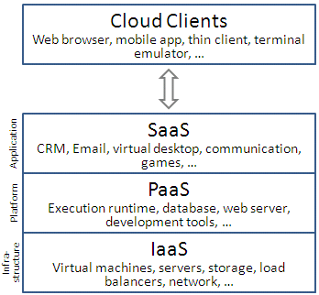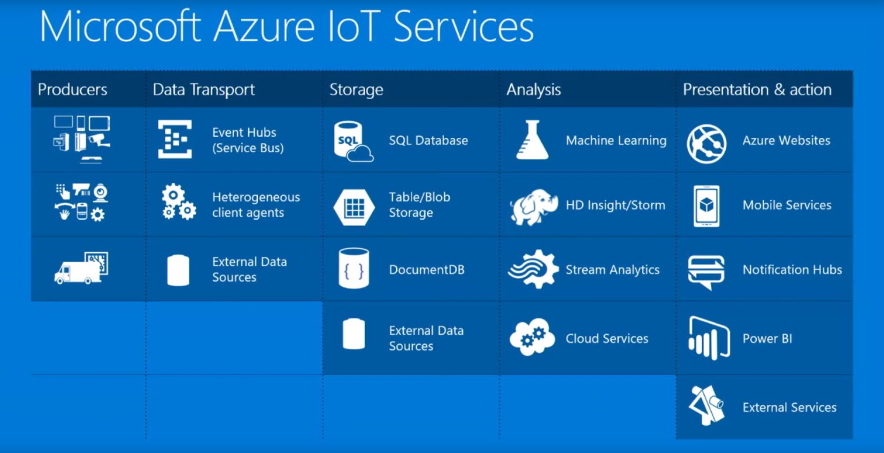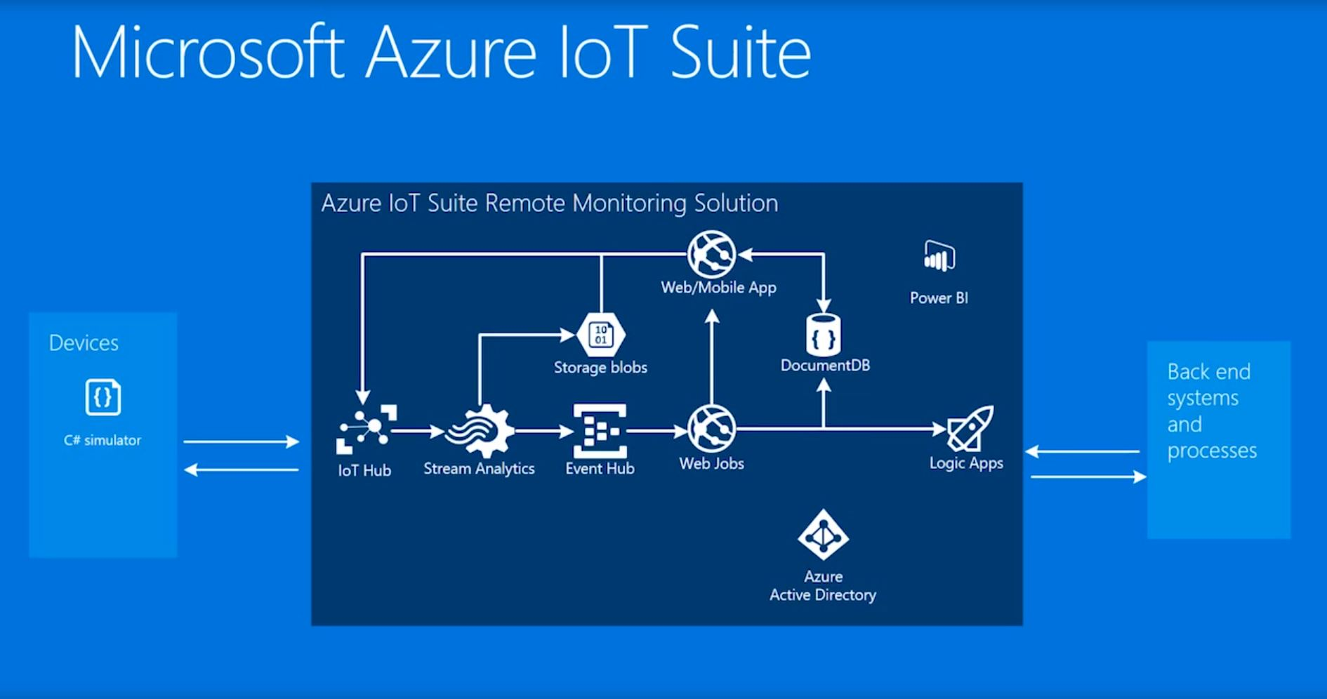

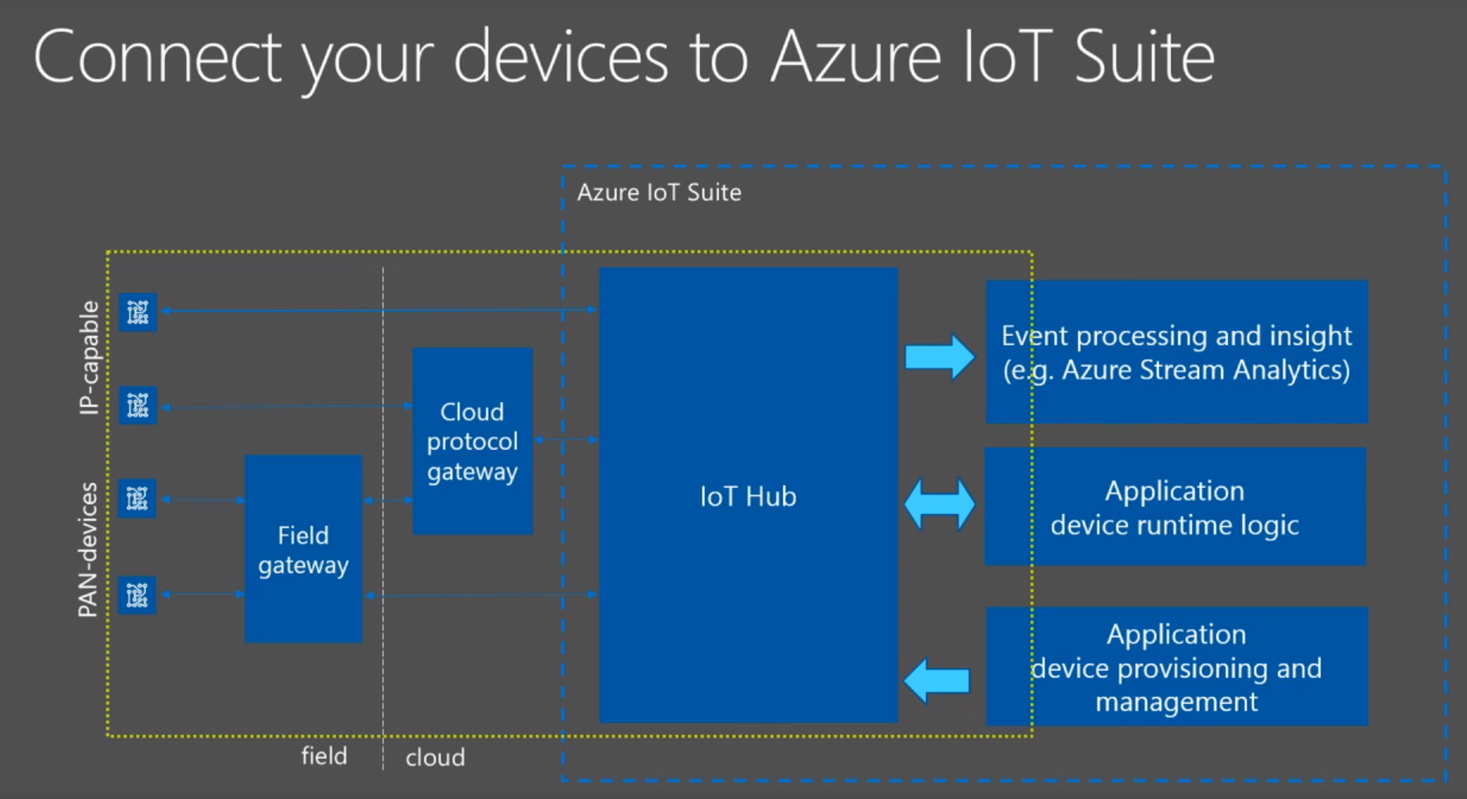

Field Gateway

* Sits between your devices and your IoT hub.
* Located close to your devices.
* Your devices communicate directly with the field gateway by using a protocol supported by the devices.
* The field gateway communicates with IoT Hub using a protocol that is supported by IoT Hub.
* A field gateway can be highly specialized hardware or a low power computer

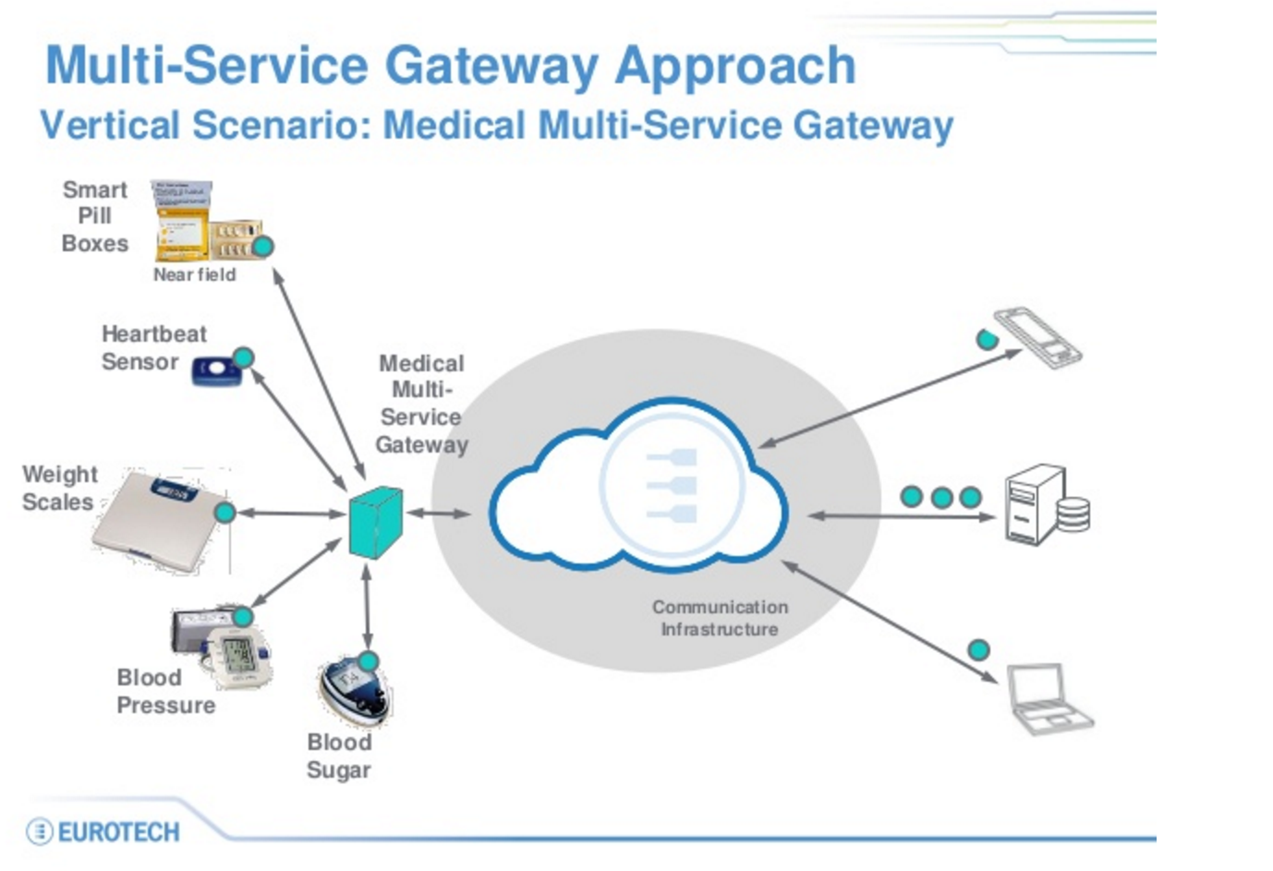

6LoPAN Network Filed Gateway

6LoWPAN is an acronym of IPv6 over Low power Wireless Personal Area Networks.

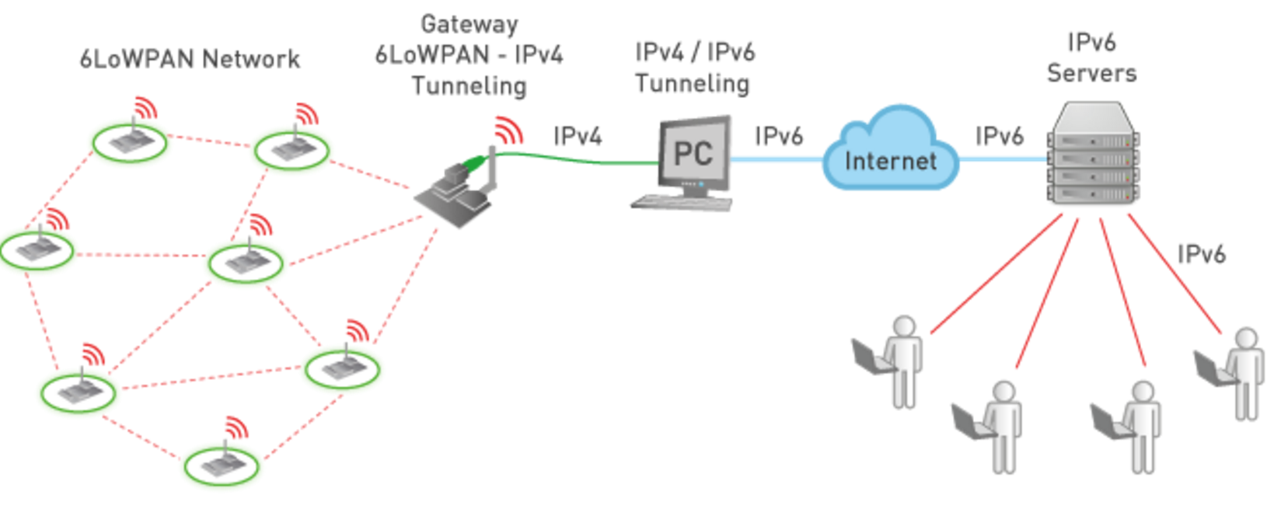

Cloud Protocol gateway

* is a framework for protocol adaptation that is designed for high-scale, bidirectional device communication with IoT Hub.
* is a pass-through component that accepts device connections over a specific protocol; AMQP and MQTT

Connectivity

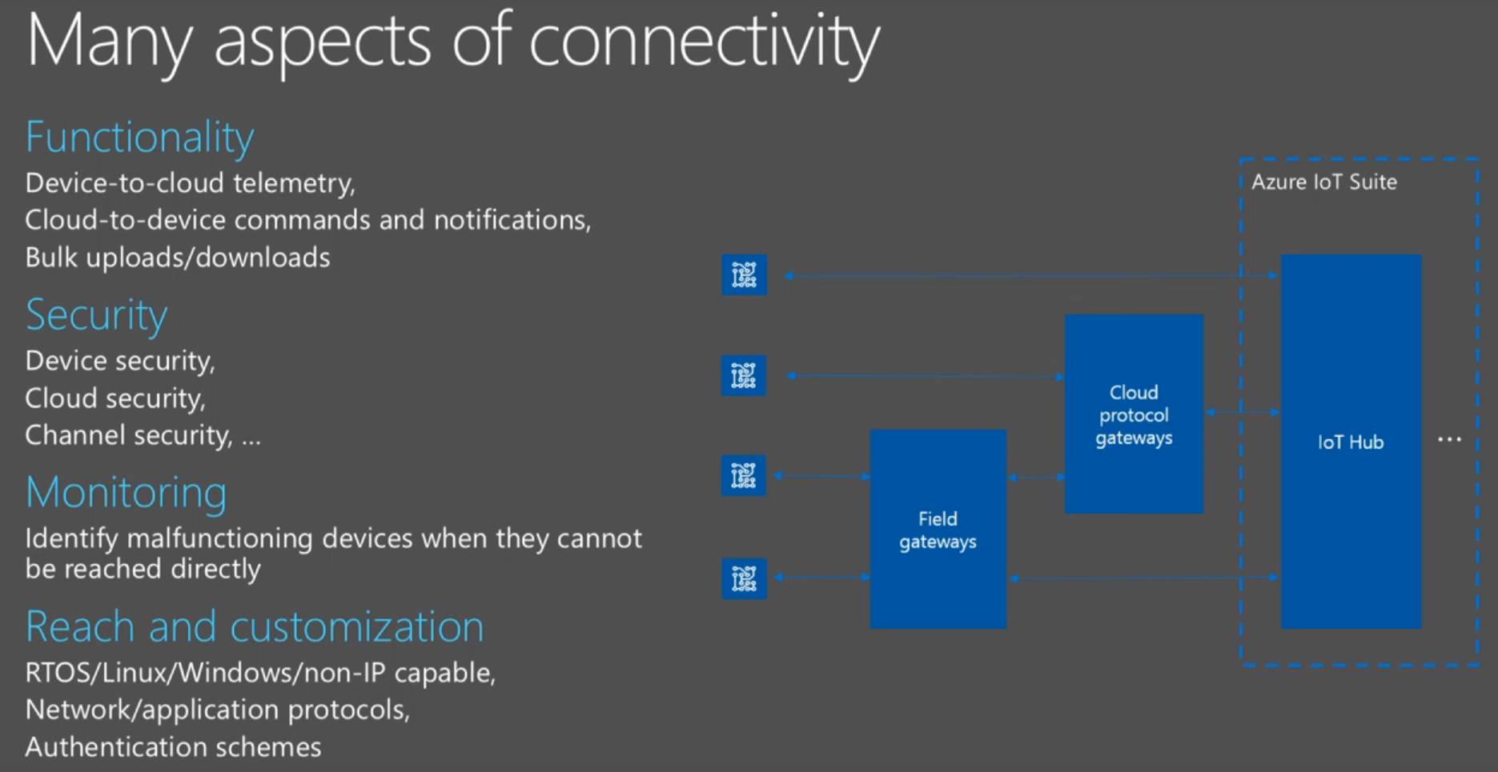

IoT Hub

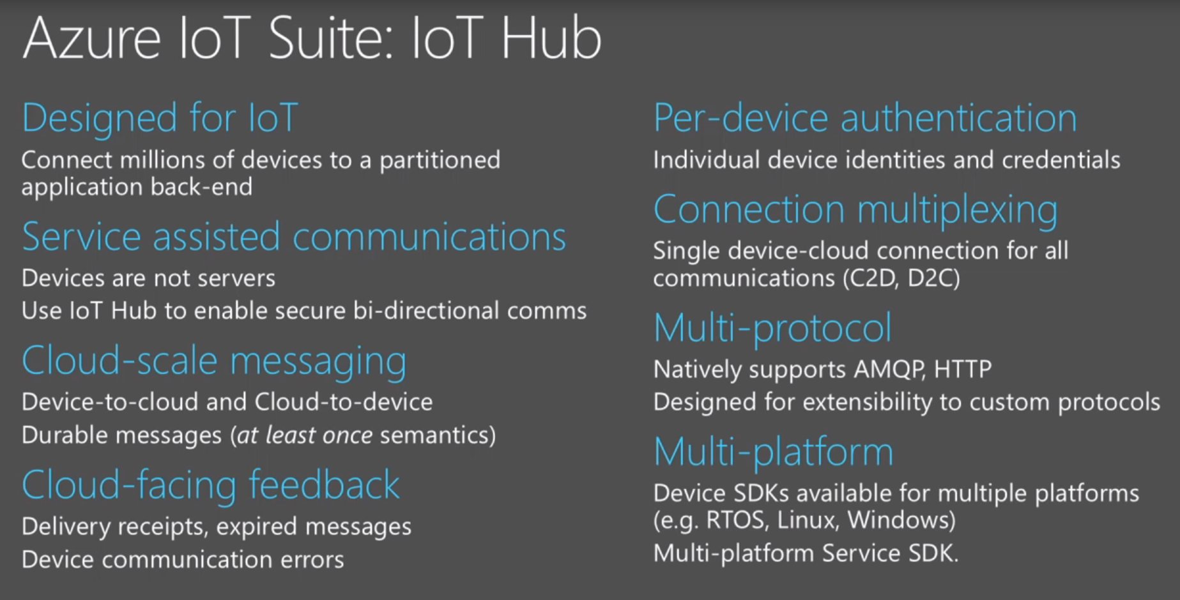

IoT Hub Endpoint

